Which one of the following is NOT a valid java.lang.String declaration ? :
a) String my string = new string ( "Hello" );
b) String my String = new String ( 5 );
c) String cde = "cde";
d) String my String = new String ( );

Write a program to print the pattern of asterisks as shown below:
****
***
**
*
public class AsteriskPattern {
public static void main(String[] args) {
// Outer loop for rows
for (int i = 4; i >= 1; i--) {
// Inner loop for stars
for (int j = 1; j <= i; j++) {
System.out.print("*");
}
// Move to the next line
System.out.println();
}
}
}
Write a Java program to find the number 1221 is palindrome or not.
public class PalindromeCheck {
public static void main(String[] args) {
int number = 1221;
int original = number;
int reversed = 0;

while (number != 0) {
int digit = number % 10; // Get the last digit
reversed = reversed * 10 + digit; // Build the reversed number
number = number / 10; // Remove the last digit
}

if (original == reversed) {
System.out.println(original + " is a palindrome.");
} else {
System.out.println(original + " is not a palindrome.");
}
}
}
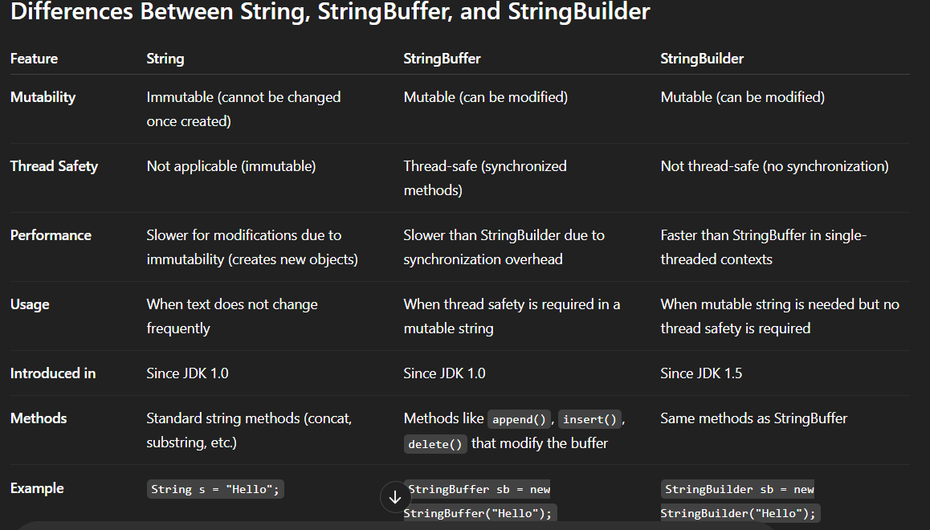
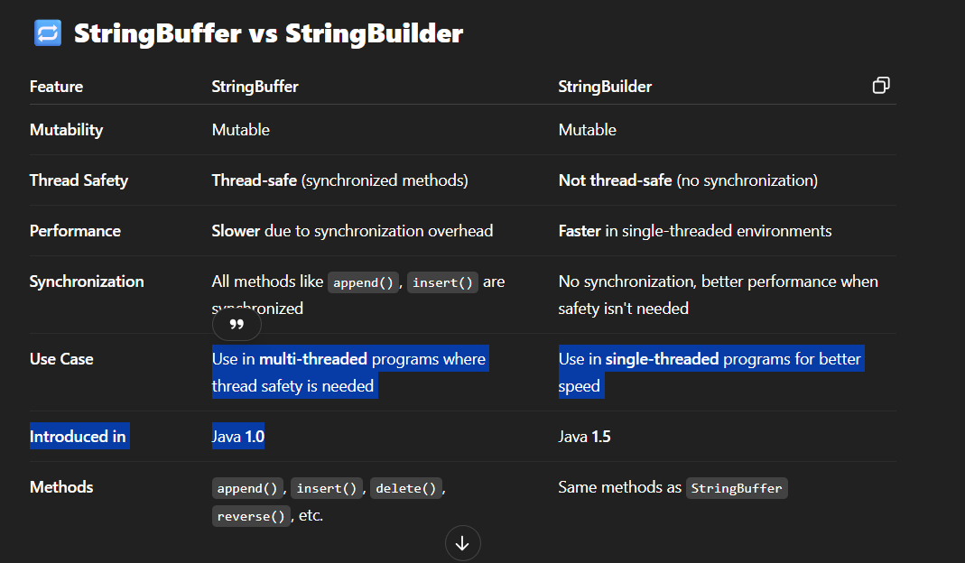
Why is String a Reference Type and Not a Primitive Type?
In Java, String is not a primitive type like int, char, or double. Instead, it's a reference type (or class type) because:

🔍 1. Strings Are Objects
- String is a class in the Java standard library (java.lang.String).
- When you create a string like:
java
CopyEdit
String name = "John";
Java is creating an object of the String class and assigning its reference to the variable name.

🔍 2. Reference Type Means Object Reference
- A primitive type (like int) stores the actual value.
- A reference type stores the memory address (reference) of the object, not the object itself.
Example:
java
CopyEdit
int x = 10; // primitive type holds value directly
String s = "Hello"; // reference type holds address of a String object

🔍 3. String Has Methods and Behaviors
- Since String is a class, it has methods like:
java
CopyEdit
s.length(), s.toUpperCase(), s.substring(), etc.
- These methods are defined in the String class, which wouldn’t be possible if String were a primitive.

🔚 Conclusion:
String is a reference type because it's a class and not a built-in data type. Variables of type String refer to objects in memory, not raw values.

